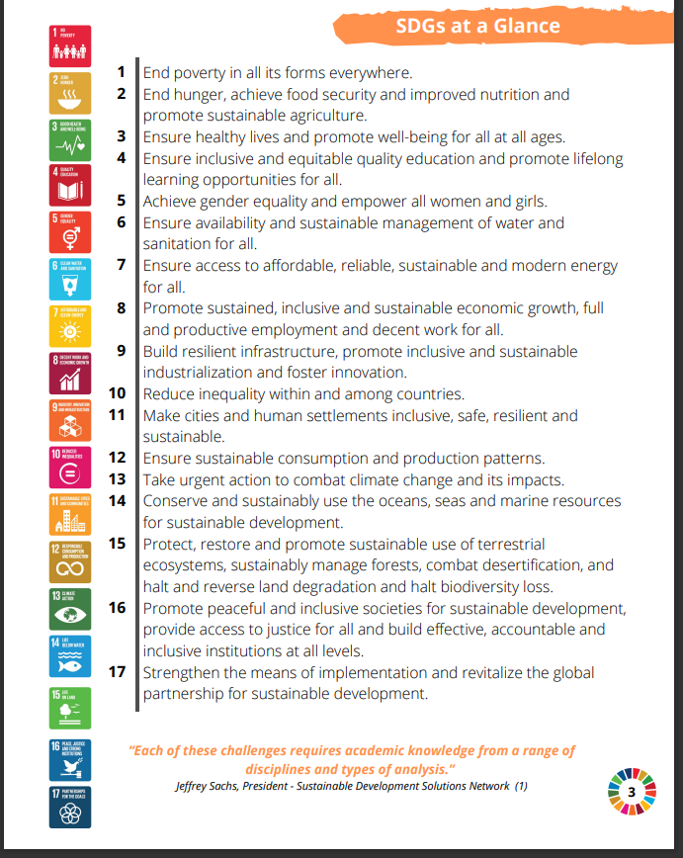

<https://www.spaceappschallenge.org/nasa-space-apps-2024/find-a-team/earth-innovators/>

[NASA Space Apps Challenge](https://www.spaceappschallenge.org/resources/project-submission-guide/) (Project Submission Guide)

[NASA Space Apps Challenge](https://www.spaceappschallenge.org/resources/judging-awards-guide/) (Project Judging Guide)

<https://asure.neduet.edu.pk/node/25> (NED SDG WEB)

<https://worldview.earthdata.nasa.gov/>

https://sdgs.un.org/goals

<https://www.youtube.com/watch?v=o08ykAqLOxk> (Ted Talk Link)

<https://www.youtube.com/watch?v=0XTBYMfZyrM> (17 SDGs Link UN)

<https://worldslargestlesson.globalgoals.org/>

<https://worldview.earthdata.nasa.gov/>

<https://svs.gsfc.nasa.gov/5115/>

<https://be-a-fact-ivist.worldslargestlesson.globalgoals.org/en> (SDG Chart Papers)

<https://worldslargestlesson.globalgoals.org/> (Lesson plan)

<https://worldslargestlesson.globalgoals.org/wp-content/uploads/2024/09/WLL-GGW-Lesson-Toolkit-3.pdf>

<https://eotoolkit.unhabitat.org/pages/eo-data>

<https://worldview.earthdata.nasa.gov/> (Earth OBS Data)

[SEDAC Map Viewer, v2 (columbia.edu)](https://sedac.ciesin.columbia.edu/mapping/viewer/) (Population Data)

the challenge, the proposed solution, and why is it important?

* What exactly does it do?
* How does it work?
* What benefits does it have?
* What do you hope to achieve?
* What tools, coding languages, hardware, or software did you use to develop your project?

### **1. SDG-Themed Images:**

* **Global Impact Scenes**: Use images that reflect the specific SDGs (e.g., people helping in poverty-stricken areas, children in classrooms, health workers, clean water projects).
* **Icons or Illustrations**: You can include slides that focus on the official SDG icons paired with relevant information. This creates a direct connection to the SDGs while adding vibrancy.

### **2. Educational Scenes:**

* **Classroom Activities**: Since your site mentions "SDGs in the Classroom," images of students engaged in SDG-related lessons or activities (like environmental projects or social studies) would be relevant.
* **Project-Based Learning**: Photos showing students working on hands-on projects that align with SDGs (e.g., building water filters, planting trees, working on community projects) can emphasize practical engagement.

### **3. Nature and Community Photos:**

* **Environmental Landscapes**: Images of forests, clean rivers, renewable energy (like solar panels), and other natural environments that reflect the goals related to climate action and sustainability.
* **Diverse Communities**: Photos that showcase diverse communities working together to solve global issues like hunger, inequality, or clean water access can humanize the SDGs.

### **4. Abstract and Conceptual Images:**

* **Abstract Illustrations**: You could include slides with illustrations or graphics that symbolize concepts like "partnership for the goals" or "innovation in education." These can help break up the realism of photos with something more creative.
* **Infographics**: Simple and clean infographics highlighting statistics related to the progress of SDGs or the importance of education in achieving them could be a good addition.

### **5. Progress and Achievement:**

* **Before-and-After Shots**: If applicable, include transformation images that show progress in communities, whether it’s improvements in health, infrastructure, or education.
* **Success Stories**: Showcase images of successful projects or outcomes related to SDGs, like children graduating from school or communities thriving due to sustainable agriculture or clean water access.

### **Image Style Tips:**

* **Consistency**: Use images that have a similar tone (e.g., all bright, vibrant, or all soft and muted) to maintain consistency across the slider.
* **High Resolution**: Ensure the images are high-quality and well-lit, as they will take up significant screen space.
* **Balance with Text**: If you plan to overlay text on the images, make sure the images aren't too busy, or apply a light overlay to make the text stand out.

Would you like help finding or selecting specific images? Or guidance on how to design and implement the slider on your site?